Creating a Next Year Requisition

_____1. From Purchasing > Next Year > Maintenance > Create/Modify Requisition, click the Add – Clear All button. This will open a blank requisition screen into which you will enter your new requisition information.

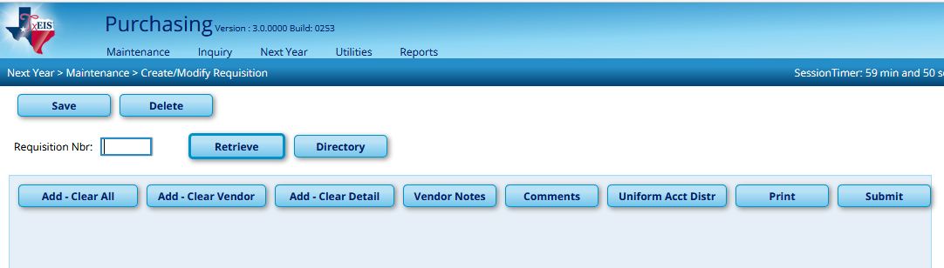

Note: Though they are seldom used, there are two other options for creating Next Year Requisitions:

- Add – Clear Vendor: Creates a new Requisition reproducing the same item detail information from a previously saved or returned Requisition.
- Add – Clear Detail: Creates a new Requisition reproducing the same Originator, shipping, and vendor information from a previously saved or returned Requisition.

_____2. Complete the information for the Requisition. There are three sections to the Requisition screen. Each of the three sections (top, middle, and bottom) is detailed below:

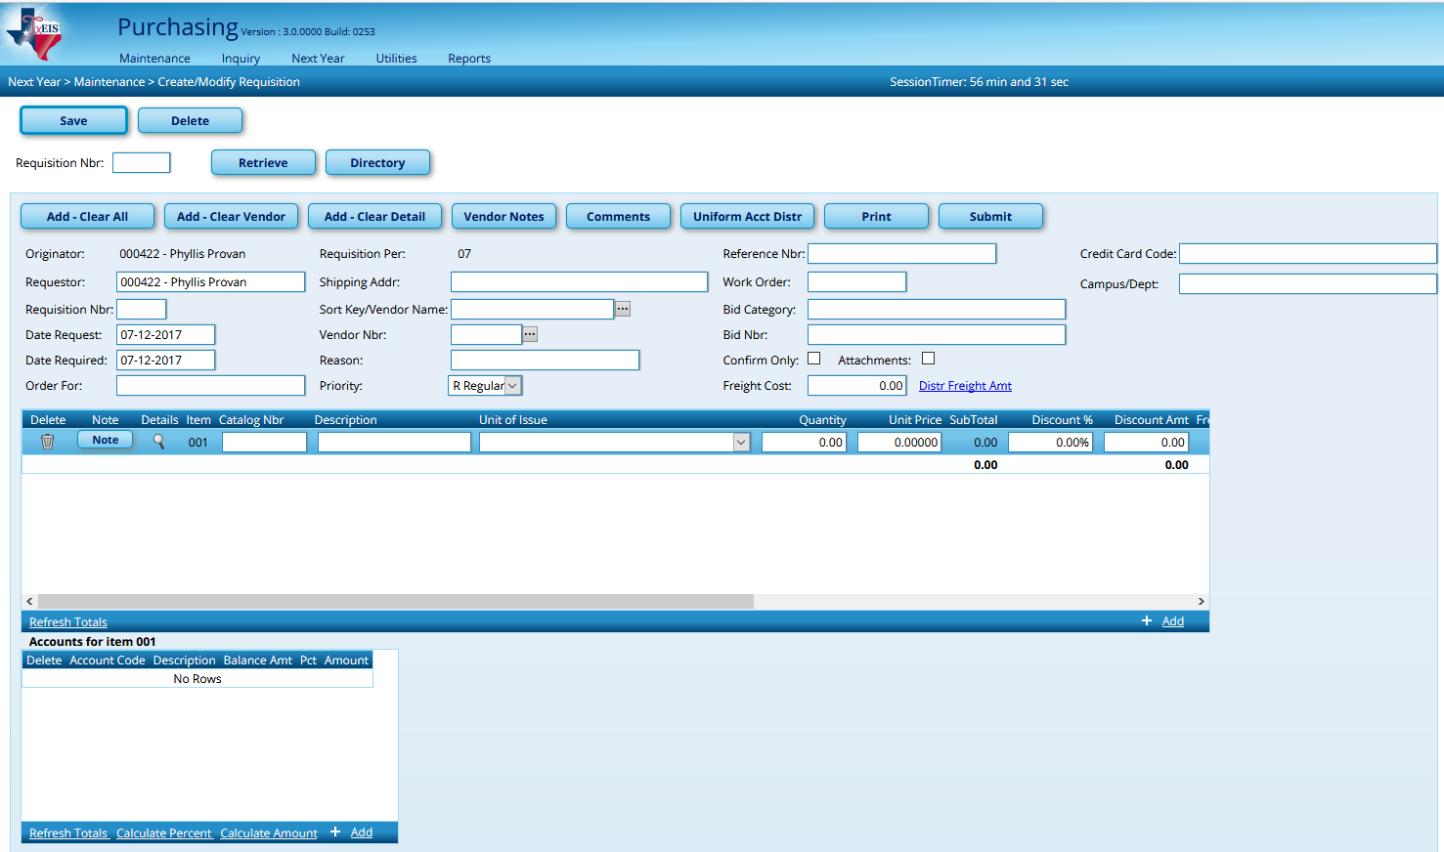
Section 2
Section 3
Section 1

Section 1 (Top)

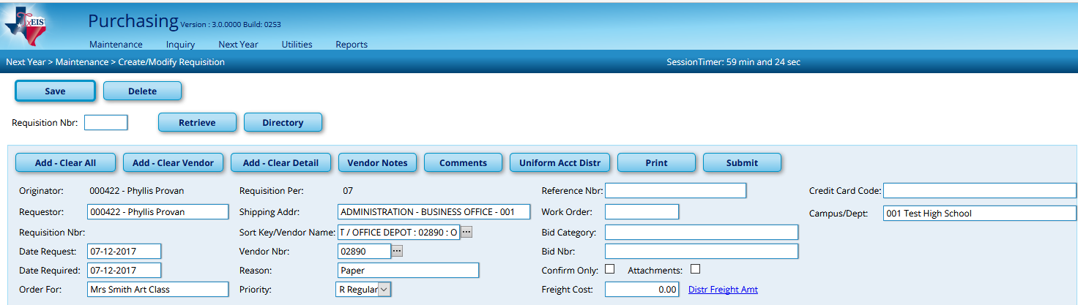

- Requestor: defaults to the originator. You will only need to change if additional requestors have been established. There is a separate space to indicate who the order is for.
- Requisition numbers: if the field is grayed out, the system will automatically assign a number upon saving. If the field is open, a number must be manually entered.
- Dates Requested and Required: default to today’s date. Change as desired.
- Order For: indicate the name of the person or group you are ordering for. This information will be printed on the PO.
- Shipping Address: will automatically populate the default address that was set up for the Requestor. Use the drop-down to pick another address if needed.
- Sort Key/Vendor Name: begin typing the vendor name to view a list of vendors beginning with those letters. Select from the dropdown. The Vendor Number will populate when a vendor is selected from the dropdown. If the Vendor that you need is not available, it will have to be built or reactivated in Finance.
- Reason: Type a brief description of the items being delivered. This information will display in the Finance General Ledger and on reports.
- Priority: defaults to Regular but may be changed to Urgent if desired.
- Reference Number, Work Order, and Bid Number: optional fields that may be utilized as needed to refer to special pricing quotes, work order numbers, etc…
- Confirm Only: select this box to alert vendors that the PO refers to an order already placed. This information will be printed on the PO.
- Attachments: select to alert approvers and vendors who receive the PO that additional information should be attached to the PO.
- Freight Cost: freight can be handled two different ways. Use this box if you want freight charged to one or more items specifically. If freight will be charged to all items equally, click the Distr Freight Amt link. Otherwise the freight will be charged proportionately to items marked as Freight Eligible in Section 2 (middle portion). The second way to charge freight is to add a separate line for freight in section 2.
- Campus/Dept: select the campus or department for whom the requisition is being submitted. This selection will determine the First Approver of the requisition. Clicking the Space bar will provide a dropdown to select from.

Section 2 (middle)

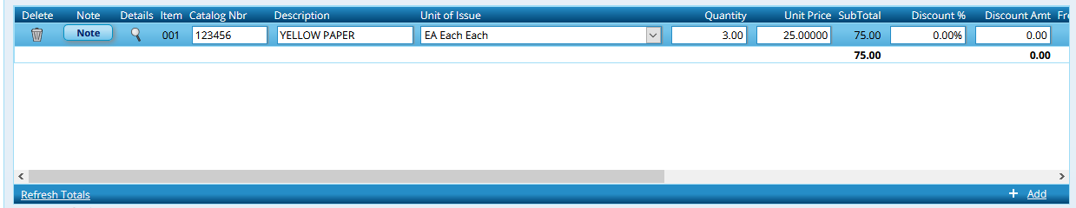
- Note: displays a pop-up box. It can be used to make a note concerning the item. This will NOT be printed on the PO.

- Catalog Number: part number of item number listed by the vendor to identify the item(s).
- Description: field holds 30 characters. If the description requires more characters, use the Long Description field.
- Unit of Issue: select from the dropdown.
- Unit Price: price per unit of issue
- Quantity: quantity per unit of issue
- Subtotal: automatically calculated
- Discount % and Discount Amount: if a discount is to be given fill in a percent or amount. You need only fill in one of the fields. The other will be auto-populated for you.
- Freight Eligible, Freight % and Freight Amount: if freight cost was entered in section 1 and the item on this line is freight eligible, check the box and enter the freight percent OR amount. You need only fill in one of the fields. The other will be auto-populated. If you are entering freight as a separate line item or the item is not charged freight, leave the box unchecked.
- Total: amount is auto-calculated based on Unit Price, Quantity, Discounts, and Freight.
- Status: defaults to Y-Yes, Approved. Can be changed to indicate item is F-Free. Requisition will not save if item has a status of Y but has no total dollar amount.
- Long Description: available for extended description if the 30 characters in the original Description field were not enough.

***Important: You must click the Refresh Totals link after all items have been entered in Section 2 to get the Total amount up-to-date. This must be done before any account codes are assigned.

Section 3 (bottom)

There are two options for entering account codes for requisitions. You may only use one of the options. Option 2 is recommended.

Option 1: After each item is entered add an account line in the bottom section. Select the Account link beside the Catalog number of each item in Section 2 (middle). Begin typing the account code desired, or click in the box and use the lookup button to search for a code. Select the desired account code. The Description will populate based on the account code selected.

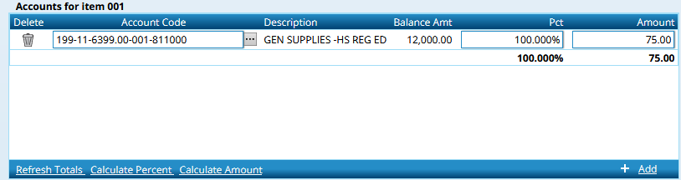

The balance in the Budget for the account code displays. (Note: a negative amount means there is money in the budget.) Items may be charged to one or more account codes. Enter either the percent or amount of the item to be charged to that account code. Add additional account code lines as desired.
Once the account information has been entered, click on the Refresh Totals link to get totals in both percent and amount and to verify 100% of the line has been expensed.

Important Note: This option is line item driven, so the account information being entered will tie solely to the item whose Accounts link was selected in Section 2.

Option 2: Option 2 is much simpler as it will distribute costs uniformly across all items based on the percent or amount indicated. After entering all items and before you enter any account codes in the bottom section, select the Uniform Account Distribution button at the top of the screen.

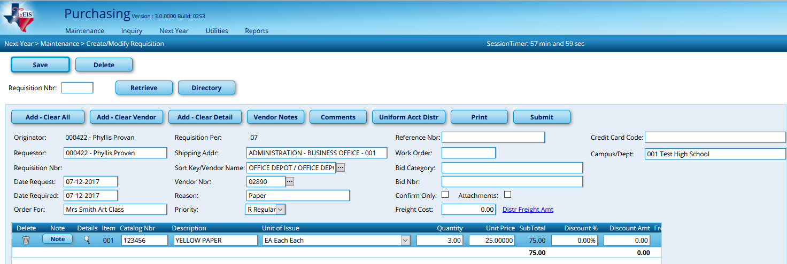

A pop-up box will display in which you will code the entire requisition. Select your account code. Just as in option #1, you will see the balance for the account and you must assign the percent or amount of the entire requisition you want charged to that account. Add additional account codes as desired.

Once all accounts codes have been entered, select the Calculate Percent or Calculate Amount link. (If you entered by amount, calculate the percent. If by percent, calculate amount.) Your percent must equal 100% and the amount must equal the total for the requisition. Once it does, click OK.

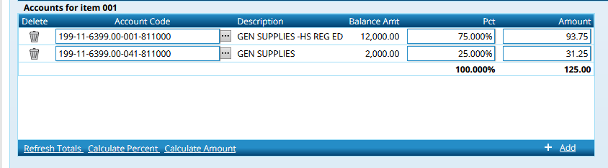

_____3. Review the Requisition and consider the buttons along the top of the screen.
- Vendor Notes: Any message typed in this box will display on the PO for the vendor to see. The text is limited to three lines that are each approximately 3 inches in length. If a Vendor Note is added, the button on the main screen will be italicized.
- Comments: Any message typed in this box will NOT be printed on the PO but will be available for approvers to see and will display on Purchase Order Reports. We recommend that approvers use this area to explain any issues that caused a requisition to be returned. If a Comment is added, the button will be italicized on the main screen.
- Print: this button will print a copy of the requisition information. Note: This is not the PO. This is the same report that will print anytime you Save or Submit your Requisition and answer Yes when asked if you would like to print the Requisition.
- Submit: will send the requisition to the next approver.
- Save: A Requisition can be saved at any time by clicking the SAVE button in the top left corner. The Requisition can be retrieved at a later date if necessary. Saving will NOT send the Requisition to the next approver. You must Submit to send it on.
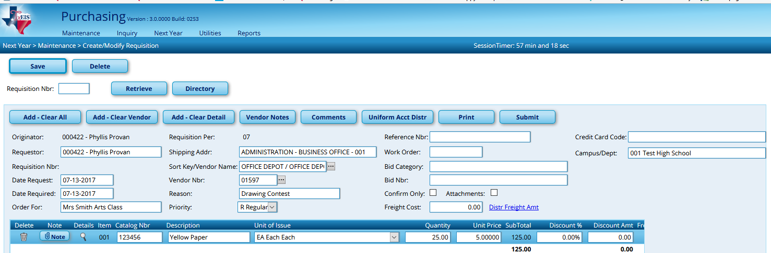

Other information on this screen
- Saved or Returned Requisitions may be Retrieved by number (if known). Type the Requisition number and Retrieve.
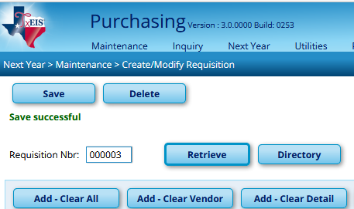

- If the Requisition Number is unknown, the Directory may be used to retrieve Saved or Returned Requisitions. From Next Year > Maintenance > Create/Modify Requisition, select the Directory button.
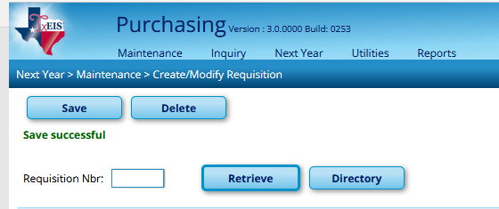
In the popup box, enter information to use in the search for a saved Requisition, or leave criteria blank and select Search. Requisitions meeting the Search criteria (or all Requisitions if criteria were left blank) appear in the list.
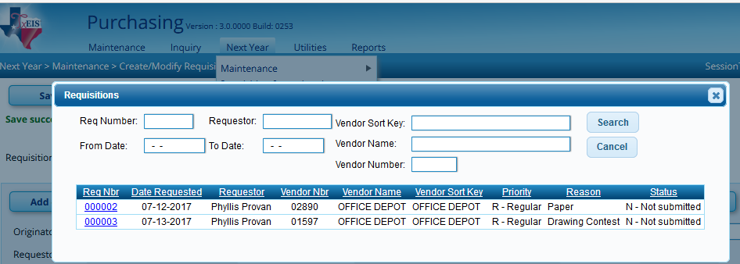

Select the Requisition Number desired and the saved Requisition will display. You may review and modify as needed and Submit. Submitted requisitions will no longer be displayed in the Directory.
- Be Cautious: Users who attempt to submit a Next Year Requisition for more than the amount listed in Budget will not receive a message to let them know and will allow them to submit the Requisition, unlike the Current Create/Modify Requisition.

- To Delete a Requisition, retrieve the requisition desired and select DELETE. You will be prompted to verify the deletion
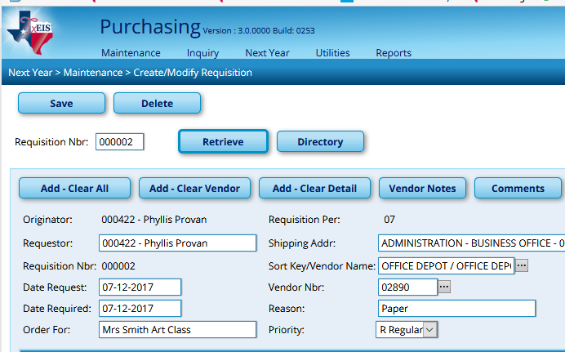

Requisition Status Inquiry

To check the Status of your Requisition, go to Next Year > Requisition Status Inquiry.

If you know the Requisition number or date range, enter information at the top of the screen and Retrieve. If not, leave the options blank and click Retrieve to see all of your
Requisitions. Select the spyglass to see the desired Requisition
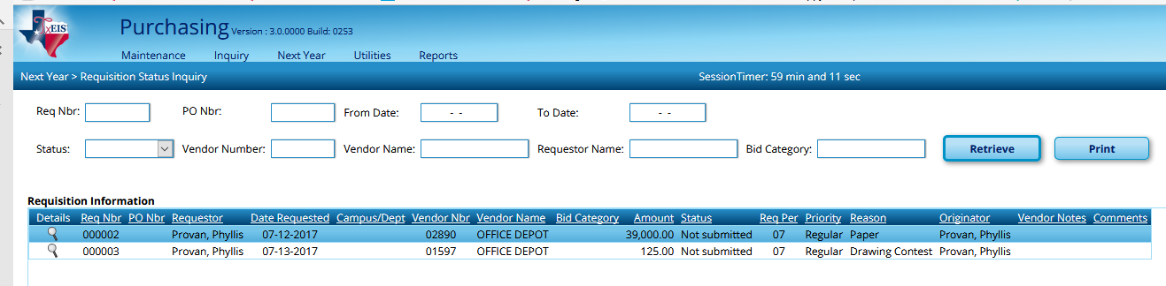

The status of the Requisition is noted in Section 1. Click the spyglass on a particular requisition to see details in Section 3, such as when the Requisition was submitted and approved, and who has it now. When the Requisition has been approved, you will see a PO number assigned and all the approvals will show in the bottom screen with dates.
